|  |  |
| --- | --- |
| Times | Grade Levels |
| 11:00-11:30 A.M. | Kindergarten |
| 11:30-12:00 P.M. | 1st and 2nd Grades |
| 12:00-12:30 P.M. | 3rd and 4th Grades |
| 12:30-1:00 P.M. | 5th through 8th Grades |

Thanksgiving Feast Schedule

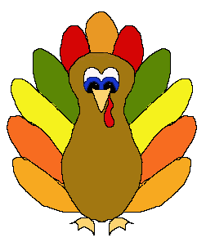Main Campus